MileStrone 2

Name: Himaeswari R K

Employee Id: 761156

Output Screens

1)Create Company

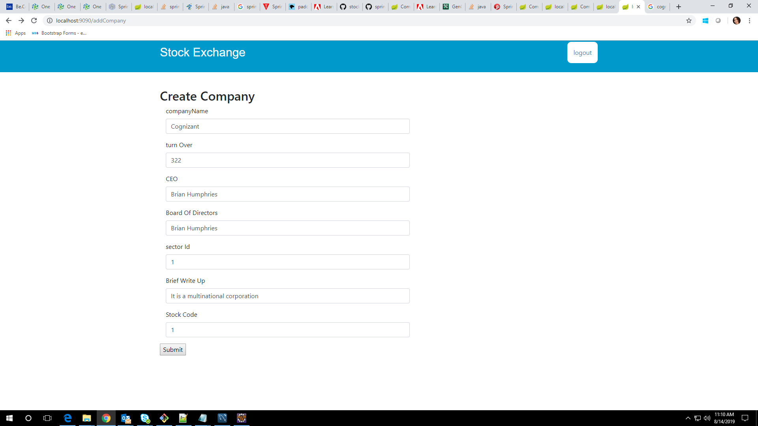

2)Company View

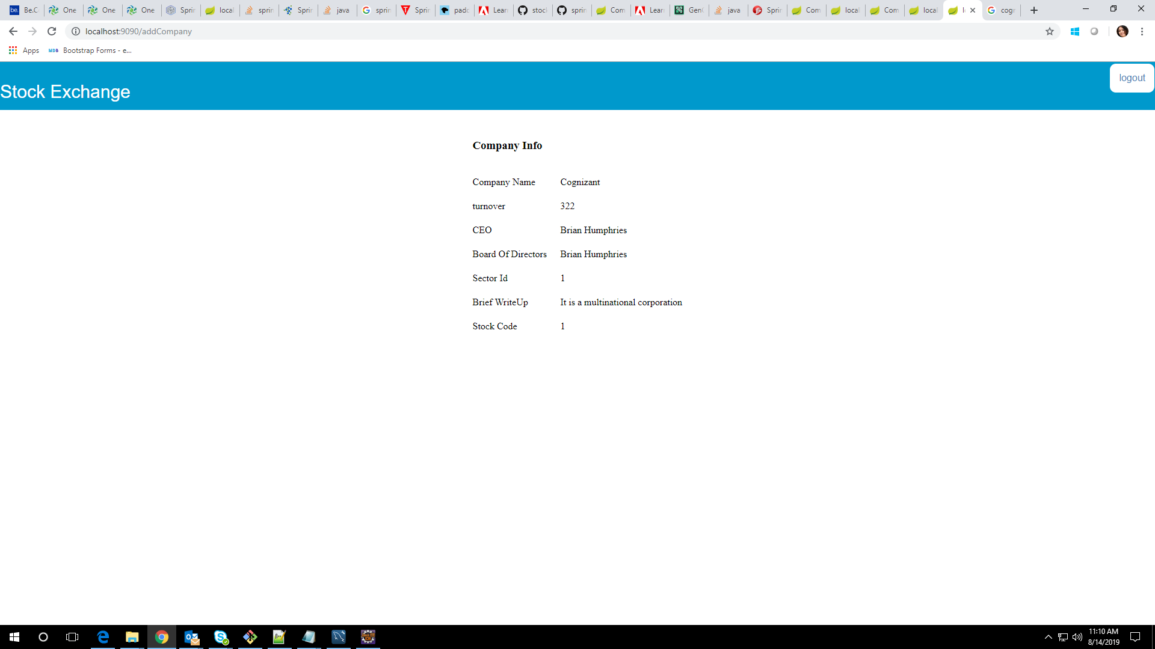

3)Company List

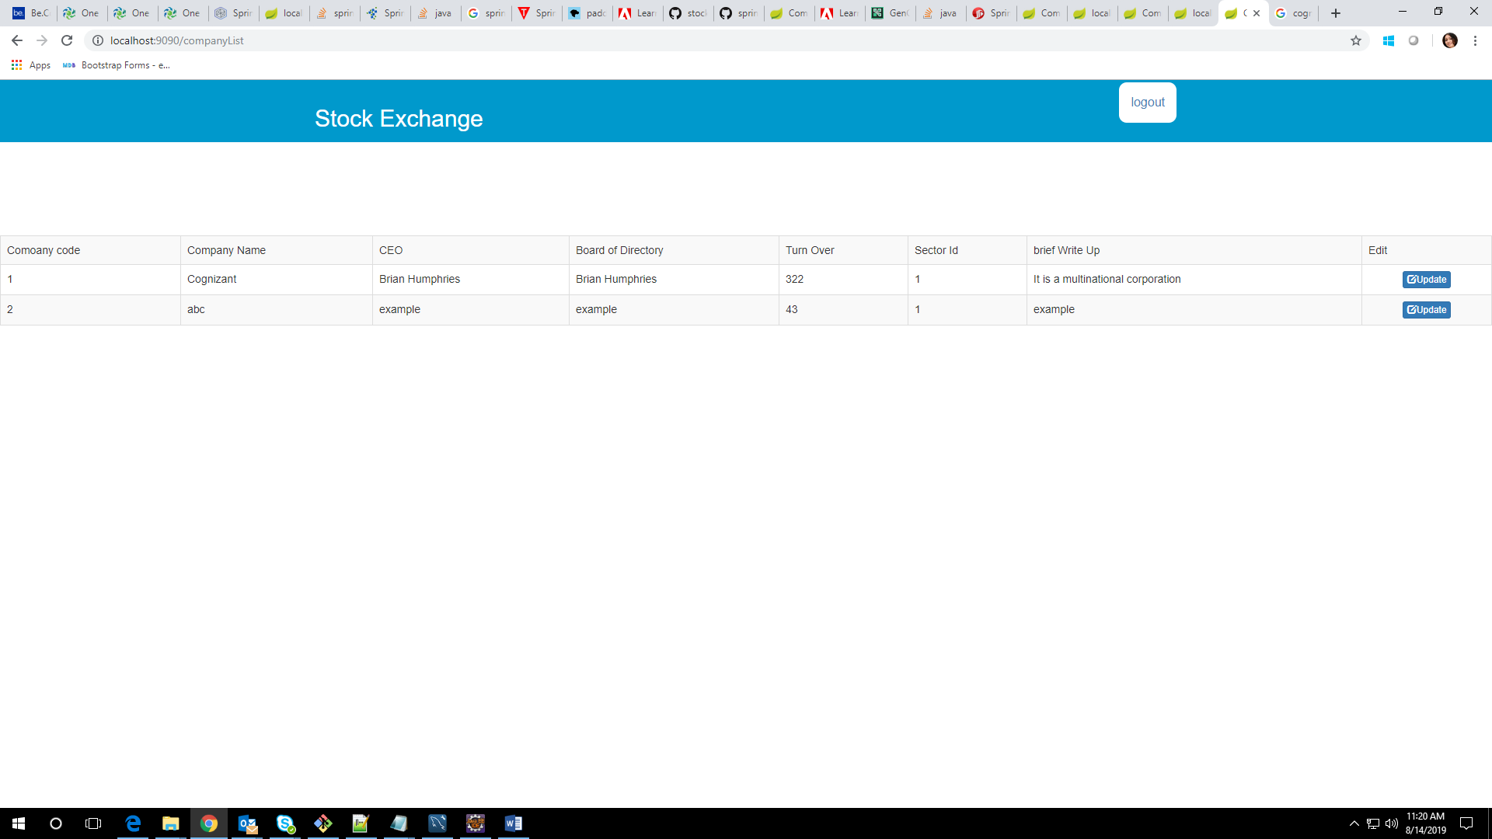

GitHub link: <https://github.com/Himaeswari/stockchart>